About

BLOG BOOKS REVIEWS READINGS Social Media DONATE









Homes Without Roofs: Escaping the Housing Shortage in Spain
admin / 10/20/2025 / 11 comments

By Jorge Galindo (Esade EcPol), author of Three Million Homes (Debate, 2025).

When you’ve published a book and are invited to speak or write about it, what you’re actually doing is rewriting it. And as anyone who’s had to go through the peer-review process for a scientific journal knows, there’s nothing as fruitful for rewriting an argument as a good critique. My favorite among the many valid critiques I’ve received has been: Why did you write a book focused on Spain when the problem of affordable housing is something that affects so many global cities?

Successful cities...

And the truth is, I could have started the book there. I could have started it with the urban economist from whom we have learned the most in recent decades: Edward Glaeser. I could have started it by quoting the line from this interview: “The more important an idea is, the more important it is to communicate it face to face.” This quote encapsulates his book The Triumph of the City (2011), in which he argues that the concentration of people in dense spaces drives innovation, productivity, and social mobility, because it facilitates the exchange of ideas and mutual learning. And, as Ezra Klein and Derek Thompson argue in Abundance, following Glaeser himself, in economies
Search

SOC

Follow

C
advice

AUT

Author

COM

Asier Antoni

In today’s world, ideas account for an increasingly large share of added value. What makes the difference is not where a computer is manufactured, but who conceived its design and the software that runs on it.

He could then have gone on to apply this to the Spanish context, taking it a step further: how all of this translates into individual gains. De la Roca and Puga tracked nearly two million Spaniards over several years and found something revealing: for every logarithmic unit of urban size, there is an immediate wage premium. Urban economics offers several explanations. The first is agglomeration economies: sharing infrastructure and deep labor markets increases productivity. The second is selection effects: the most skilled workers tend to concentrate in cities. And the third is learning: dense networks and spillovers raise the value of human capital acquired in urban environments. If, in addition to agglomeration (which is the Glaeserian argument), only selection effects were at play, cities would reinforce pre-existing inequalities. But De la Roca and Puga show that the premium grows over the years and persists even after leaving the city.

It is one of the most beautiful findings in urban economics: the imprint cities leave on life trajectories. That is why Puga and de la Roca, along with Glaeser, are cited in the book. But it does not start there; rather, it begins with the flip side of this dynamic. I began with what, for me (and for the Bank of Spain, BBVA Research, CaixaBank Research, José García Montalvo, and José María Raya, among many others), is the heart of the problem in Spain: the relative shortage of housing where people want to live.

...and rising demand...

Having a roof over one’s head near where opportunities, added value, and face-to-face ideas are found is the necessary condition for being able to contribute to and benefit from this momentum of people coming together. But in Spain, the challenge we face here is enormous.
Let’s start by looking at the long term and then move on to the short term. The INE forecasts the formation of 3.7 million new households. Behind that figure lie two likely factors that help explain why this is expected despite demographic stagnation: increased migration—a net inflow of 642,000 people in 2023, the highest in the EU
— and smaller households, with the average size dropping from 2.5 to 2.32 people. And one-third of all households will be single-person households.

Of course, these 3.7 million would not be distributed evenly. Madrid will gain
comie

Antoni eats

Antoni eats

Juanm

NUB

DES

I'M HUNGRY
E
CRI NAD CAM
RE
POL UNI REC IMP CRE COR PEN
HI

CAL

576,000 households: Valencia (238,000), Alicante (247,000), Málaga (211,000), and Murcia (164,000). At the other end of the spectrum, Zamora has just 1,300, Palencia 2,100, Soria fewer than 5,000, and Teruel 9,600.

Added to this is the fact that cities attract people not only to live there but also to visit. In 2023, Spain broke its pre-pandemic record: more than 85 million international tourists, and the Ministry forecasts 94 million in 2024. The number of tourist accommodations registered by the INE has grown by around 75% between 2016 and 2024. At the same time, another market is on the rise: seasonal rentals. In a study we published led by José María Raya, we saw that in Barcelona, their share rose from 2.1% of listings in 2019 to 14.4% in 2023—a sevenfold increase. In Madrid, it rose from 3.3% to nearly 10%—a threefold increase.

And all of the above also contributes to the appeal of investing. According to the Bank of Spain, the average annual return between 2015 and 2022 was 10.5%, combining rent and appreciation; rent alone contributed 5.5%. This is a far cry from 2011–2014, when returns were negative. Driven by all of this, today, certainly, sales are at record highs: but almost all of them involve existing homes, as shown in the following figure:
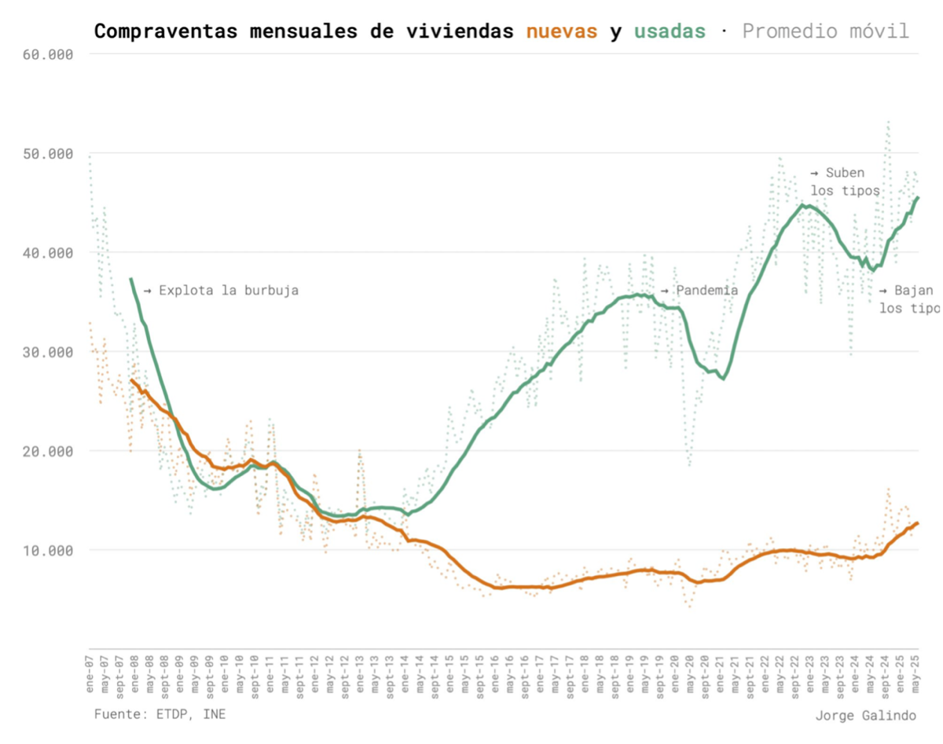

In short, what we have is a market of scarcity, in which it seems that supply is not

L

4
11
18
25
« Sea

MAR

2026

2025

2024

2023

2022

2021

2020

2019

2018

2017

2016

2015

2014

2013

2012

2011

being able to meet the demands.

...with a supply that does not meet

In one of the official presentations accompanying the Bank of Spain’s Annual Report in 2023, it was estimated that the cumulative housing deficit in 2022–2023 was around 375,000 units, and that, based on projections for household formation and ongoing construction, more than 225,000 would be added between 2024 and 2025. This concluded the headline that dominated media reports on housing for a year and has become etched in the collective memory: the new housing shortage “could reach around 600,000 units by 2025.”

Other sources have recently arrived at similar figures, albeit using different methods and time frames. CaixaBank Research (2025) estimates a cumulative housing shortage between 2021 and 2024 of between 515,000 and 765,000 units. FUNCAS (2025) estimated that the deficit “is approaching 600,000 units.”

Meanwhile, in 2024, only 128,000 new homes were started, as measured by building permits. This is well below what is needed to reduce that cumulative deficit. The trend so far in 2025 is barely 11% higher. And this is happening while households continue to form, albeit at a slower pace—likely due to the housing shortage itself. In the end, there were about 111,000 new households, when the forecast had pointed to three times that number. This slowdown aligns with another statistic: the rate at which young people leave their parents’ homes continues to fall. In 2015, 58% of people aged 18 to 34 in Spain lived with their parents or depended on their income. By 2024, that figure had risen to 67.2%. If we take the population of that age group as of January 1, 2024—about 6.13 million people, according to the INE—the comparison with the European average (just under 50
%) suggests a huge gap: 1.65 million more young people still living with their parents. Given an average household size of about two people, that amounts to roughly 800,000 households that do not yet exist.

There are many reasons for this stagnation. I go over them in the book, but the truth is that this masterful 2024 report from BBVA Research does a much better job: It discusses the meager budget for public housing, the rising cost of materials following the pandemic, the shortage of sufficient labor (no sector has seen unfilled vacancies grow as much) and the aging of the remaining workforce, the lack of credit for development, and low productivity (25.4% below the average for our economy!). But above all, the report delves into regulatory bottlenecks. Both those that, over the last decade and a half, have added checks, requirements, and players with veto power in the
2010

2009

the arduous process of converting available land into developable land and then into finished homes, as in the most recent regulations, which only introduce legal uncertainty and disincentives.

And when that happens—when supply consistently falls short, when it cannot meet demand—the result is, first and foremost, a price increase, of course: a cumulative rise of 58% in purchase prices between 2015 and 2023, or 47% in rent. Or a 12.8% increase between 2024 and 2025 in the Eurostat index, doubling the EU average during this period.

But there are also measurable losses in GDP and well-being. Let’s look at some literature on the subject: in the United States, Chang-Tai Hsieh and Moretti estimated, using a spatial equilibrium model, losses in GDP and well-being of between 3% and 4% annually for the entire country due to metropolitan areas that restrict growth. In contrast, in a city like São Paulo, allowing high-rise construction around transportation corridors increased the city’s GDP by 0.75% according to estimates by Anagol, Ferreira, and Rexer. In China, when urban planning regulations became stricter
—which Wang et al. measure through a reduction in the floor area ratio—, employment growth fell by between 1.1 and 1.6 percentage points for each unit of tightening of those regulations.

Unlocking OTF countries

But what happens when supply does respond? According to recent evidence, prices suffer. What is also interesting about the studies I cite below is that they all provide data to counter the usual fears surrounding new supply (such as that, as a neighborhood improves by attracting more people, this effect will dominate over others; or that the outcome will be purely positive only for higher-income households):

- Asquith, Mast, and Reed observe that the entry of new market-rate buildings

reduces rental rates in the surrounding area by between 5% and 7%. They believe the results are driven by the fact that the new buildings "absorb high-income households" and simultaneously "increase moves into these neighborhoods from low-income areas." This suggests that there could be "relocation chains" that likewise take pressure off rental prices and promote upward mobility.

- Andreas Mense uses weather-related delays during construction as a way to identify unexpected increases in completed housing. What he finds is that a 1%

more new supply reduces rents by 0.19%, particularly for lower-quality housing. And also in the tightest markets. Mense, in fact, makes direct reference to the chain reactions that could be freeing up housing across all market segments.

- In New York, Xiaodi Li shows that a 10% increase in housing within 150 meters leads to about a 1% drop in rental prices, with declines in sales prices as well. Li does identify (via new restaurants) improvements in the attractiveness of the neighborhood, but confirms that the effect of supply on the net reduction is greater.

- And in San Francisco, Pennington notes that "rents drop by 2% on properties located within 100 meters of a new building." He adds, quite significantly: "the risk of tenants being displaced in a low-income neighborhood is reduced by 17%."

The usual caveats

We can—and must—leverage what already exists: the BBVA Research report itself highlights the potential impact of tourism demand on existing housing stock. But the numbers don’t add up if we stop there. Take Barcelona, a prime example of the competition for limited space between tourists and residents: Airbnb has about 11,000 active listings in the city, according to data from Inside Airbnb. We can also add those that remain vacant: the City Council identified
About 10,000 vacant homes out of more than 100,000 inspected as probable cases (well below the figures from the INE, which in its 2021 Census estimated around 75,000 homes based on electricity consumption—a method that can overestimate in exceptional circumstances such as during the pandemic years). If we put it all together, we would be talking about between 20,000 and 30,000 homes potentially recoverable for the residential market. The INE projects the creation of 480,000 new households in the province of Barcelona by 2039. Although the city accounts for around 30% of the provincial population, even if we assume a growth ratio of three to one between the province and the capital—when in 2023–2024 it was only 1.65 to one—these 20,000 or 30,000 homes would not be enough to absorb the demand that will be concentrated in the city.

And that brings me back to the starting point: honoring the successful trajectory of our cities. Allowing supply to respond more freely to a demand that continues to grow precisely because there are both economic and (albeit

somewhat disconcerting) demographic factors.

As a corollary, we cannot overlook the central political-economic dilemma inherent in all of this: doing so would mean reducing the relative value of existing assets. At least compared to the counterfactual scenario, which is the current market of scarcity. In a country where 74% of the population owns property and around 80% of assets are non-financial (mostly housing), the conflict is evident. The “homevoter theorem,” formulated by William A. Fischel around 2001, posits that homeowners tend to vote and lobby for local policies—on public spending, taxation, and, above all, land regulation—that protect and reinforce the value of their homes. Although, to be honest, my impression of this reluctance is better captured in a recent study that uses surveys to show that most people simply do not believe that increasing supply reduces prices, as seen in the following figure. The proportion of those who hold this view is much higher in the housing market than in any other market. This goes beyond material incentives to limit supply, encompassing initial positions that make it difficult to imagine a different equilibrium.

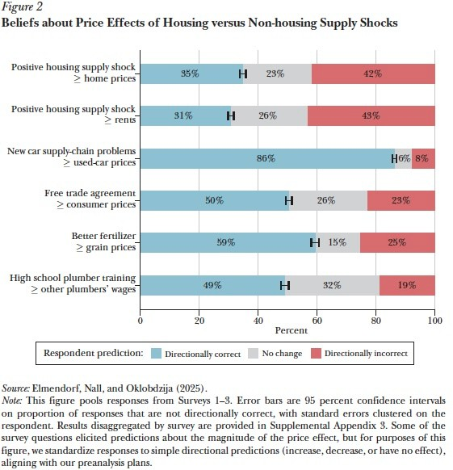

Along these lines, perhaps the applied research agenda in Spain could contribute significantly to the problem of housing access by advancing this literature: better understanding the resistance, incentives, and beliefs that hinder the supply response. But, on a more prosaic and immediate level, we also need to fight the battle of ideas, to honor those who want—and need—to live in our cities. One possibility is to change the framework. To shift from talking about “building housing” to talking about what we want our new neighborhoods to be like. Not just how many homes are needed, but what kind of urban spaces we want to create: how they connect, how uses are mixed, how they are sustained over time. Perhaps in the eternal rewriting of the book, instead of titling it Three Million Homes, I would call it The Thousand Neighborhoods Where People Want to Live.

Thank you for reading our blog. Nada es Gratis is partially funded by membership dues from the association of the same name, but to carry out its activities it needs the

A generous donation from anyone who wishes to support their work.
Donate here.







by admin Tags: cities, shortages, households, housing


ADMIN


THERE ARE 11 COMMENTS


JOSÉ MARÍN ARCAS says:
10/20/2025 at 9:37 AM
An excellent, rich, and rigorous overview. It would be interesting to compare the current pressure on housing prices with the experience of the early years of this century.



JM says:

SEVERINO says:
10/20/2025 at 6:12 PM
I think what you’re saying makes a lot of sense. Although, in my opinion, these are policies that need to be alternative. A path toward dignity, access to technology, and the revitalization of rural areas or depopulated regions, to make those areas desirable and profitable for citizens. That must be complementary to a
10/20/2025 at 2:55 PM
Encouraging the entire population of the country to concentrate in a few cities, leaving rural areas even more depopulated, does not seem like an ideal goal either. High prices in high-demand areas discourage the absorption of more people into these areas. Intervening in the market will contribute to congestion in large cities, whose costs may outweigh the economies of agglomeration.



SEVERINO says:
Supply where demand is currently highest, and studies show that there is greater value for both citizens and the country when analyzed together.

These higher returns for citizens and increased productivity, combined with a large supply that drives down prices in areas of high demand and population density, could lead to higher personal incomes and improved living conditions in rural or depopulated areas.
I believe these different perspectives should be complementary and mutually supportive, not mutually exclusive.

The problem facing depressed areas today is not housing, but their economic depression, and to address this, we must improve their infrastructure and living conditions, which will lead to greater interest among citizens in making these areas their home.

JM says:
10/20/2025 at 8:16 PM
Yes, I completely agree. We need a policy that promotes economic activity in rural areas. But if, in the meantime, we allow depopulation to continue, there will be no one to benefit from such policies, and therefore they will be difficult to implement.
10/20/2025 at 2:56 PM Thanks, Jorge,
An article based on rigor and reality, without getting caught up in the sterile demagoguery of today’s polarization that prevents us from talking about the reality of things.
The financing situation from 2008 to the present has demonized housing construction. Seventeen years without the production of the raw material for living—that is, housing—means the market has collapsed. The construction sector has died out; we almost have to rebuild it from scratch after 17 years of extreme labor scarcity. The government and politicians, who have turned a blind eye for 17 years to this situation of total paralysis, will not acknowledge their inaction, their lack of foresight, or the fact that they are the main obstacle and source of problems in providing housing for citizens—creating hundreds of thousands of pages of bureaucratic red tape through state, regional, and local regulations. Every civil servant wants

to write a rule to ban something and exert a little control.
So we find that we have come to believe that if an organization provides a thousand affordable housing units—something that has long been a social aspiration—it has now become a scandal that provider of social good is a “large landowner” and therefore must be punished for doing
what society needs, with higher taxes, by altering its contractual rights, and by defaming it as a speculator (what a rich concept that works “for everything,” even though no one really knows what it means, ....

I appreciate this post, which focuses on reality and provides a wealth of data that can help us take action.


EMPRESAS VALENCIA says:
10/20/2025 at 3:45 PM
A very good approach to focus on supply and not just on demand-side fixes. I agree: without more usable land, predictable permits, and processing costs kept in check, any assistance ends up being passed on to prices. To make a difference, three ideas work for me:

Regulatory predictability and a one-stop shop to shorten processing times;

Densification in areas with transportation and services, with clear quality standards;

Activating public land via surface rights and promoting industrialized construction to reduce costs and time.
I hope we systematically track permit processing times and cost per square meter by city: what gets measured improves.


JKL says:
October 21, 2025, at 8:32 p.m.
From a macroeconomic and structural perspective, the dynamics of the Spanish residential market reveal a mismatch between the supply of new housing and demographic pressure, particularly stemming from net immigration. Empirical data indicate that additional population demand, without a proportional increase in residential supply, generates inflationary pressures on housing prices and compromises affordability—a phenomenon widely documented in the post-crisis period and still prevalent today.

The analysis of productive capacity benefits from historical and comparative references. In advanced Eurozone economies, aggregate investment in the construction sector—which includes residential construction, renovation, infrastructure, and public facilities—typically ranges between 7% and 8% of GDP. This range is considered optimal, as it allows for meeting residential and public demand, maintaining adequate levels of employment in construction, and avoiding

sectoral overheating.

Spain has experienced atypical episodes of high investment, such as in 2006–2007, when construction accounted for approximately 12% of GDP—a figure significantly higher than the European average and associated with the formation of the housing bubble. In terms of residential production, even under conditions of high efficiency and available resources, the system has historically reached 130,000 homes per year, a figure that requires proportional adjustment



CASADO SOBREPERE, JORDI says:

NABURU38 says:
10/27/2025 at 10:05 PM
I’m from Montevideo, Uruguay. Here, they keep building entire neighborhoods with 15-story buildings, right up against each other with no setbacks, on narrow streets. There’s no sunlight even at noon.

If tall buildings must be built to increase supply, they should at least have four facades and 45-degree setbacks facing the sun.
10/22/2025 at 7:23 AM
Call me crazy, but since we’re building anyway and with all these regulations, I’d add a condition for new construction: to address density or concentration per new developable land.
This would mean that if I have a plot of land to build an apartment block, instead of making it 6 or 12 stories tall—if circumstances and the land allow it, based on the density or concentration of demand—I could build it 24 or even 64 stories tall, as is already the case in other countries where there is little developable land and soaring demand.
This "Benidorm"-style skyscraper policy would clash with the "Marbella"-style ideology of one house per plot. For purely aesthetic, rather than functional, reasons.
In any case, the construction of residential skyscrapers would multiply the supply in a sector unaccustomed to this type of building and would make much more efficient use of the scarce developable land that still exists.
Best regards.


JM says:
October 22, 2025, at 3:34 p.m.
7% of home sales are made by non-EU foreigners; see

https://www.registradores.org/actualidad/notas-de-prensa/-
/asset_publisher/VkEXepWEVFi3/content/real-estate-registration-statistics-2024-yearbook

It seems logical to curb this trend, either by banning it or by imposing a very high tax.


JSJSJS says:
10/23/2025 at 8:32 PM
So, not a word about curbing speculative buying, and absolutely no effort to encourage people to live in areas where housing is available by better distributing investment—nothing. The solution is for everyone to flock to the same eight cities as always.

Comments are closed.

NOTHING IS FREE LATEST POSTS | TE
    The end. And a new beginning.  03/27/2026  The goal of Nada es Gratis is to promote the  analysis and commentary by prestigious  A blow to the public coffers:  economic researchers regarding the does it generatetourismthegrowth  main problems facing the First Division?  society today, with special attention to March 26, 2026  Spain.    Evaluating results, not intentions: challenges of evidence-based policy evaluation  evidence | Ed
 | Co
 | An
 | Ad
 | Ne
 | Ne



Copyright © 2016 Nada es Gratis | Executive Editor: @kamromero
March 25, 2026

